Project

Project Run successfully without errors as below:

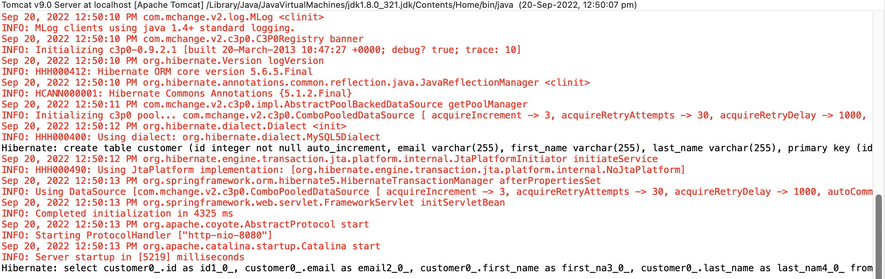

Currently there are no rows in the table so result page is empty

Table details in the MYSQL database:

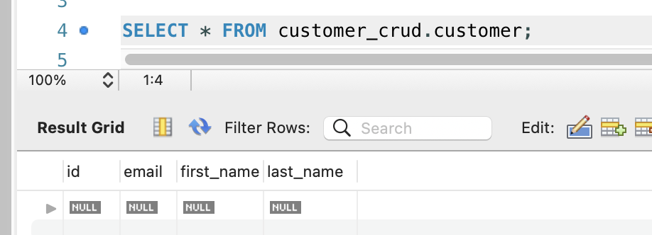

**Add Customer Functionality testing:**

Add Customer button will be redirected to a new form page, wherein the user will enter details and save.

Click on Add Customer button

It shows below customer form. Enter the customer details to add a new Customer.

click on save button to save the customer.

Once you click on save button it to a new page which will consist of a form to add the customer details also displays the latest customer details as shown below.

Table data in the database:

Added few more new customers. Below are the latest customer details.

**Update Customer Functionality testing:**

Upon clicking the update button the user should be redirected to a new page which will consist of the form same as save page with pre populated data, after updating the details, upon click on save button, new data should persist in the database.

Updating customer Maria Martinez. Click on Update link.

Update the customer details. In this case I am updating the last name and email as below. Then click on the save button

Changed the last name to Rodriguez

Changed the email address to dummy@email.com

Customer details are updated successfully as shown below.

**Delete Customer Functionality testing:**

Upon clicking the delete button, a pop up is generated, once user clicks Ok then customer entry should get deleted from the database

Deleting the customer James Johnson

After deletion below are the latest customer details.

